Implementing an Information System for Reporting Cases of Missing, Abducted, Runaway, Throwaway, Abandoned, Found and Unidentified Persons

Rey Vincent P. Babilonia
March 2009

This project is submitted to the Faculty of Information and Communication Studies in partial fulfillment of the requirements for the degree Master in Information Systems at the University of the Philippines – Open University, Los Baños, Laguna. It is the product of my own work except where indicated in the text. The project report or any portion thereof including the source code or any section may be freely copied and distributed provided that the source is acknowledged.

This project proposal entitled “Implementing an Information System for Reporting Cases of Missing, Abducted, Runaway, Throwaway, Abandoned, Found and Unidentified Persons” submitted to the Faculty in Information and Communication Studies, University of the Philippines – Open University, Los Baños, Laguna in partial fulfillment of the requirements for the degree Master of Information Systems is hereby accepted.

_____________________
Mr. Al-Francis Librero
Faculty-in-Charge, IS 295A
Date: ________________

_____________________
Dr. Alexander Flor
Dean, Faculty of Information and Communication Studies
Date: ________________
Abstract
The lack of a centralized service for disseminating advisories, a joint effort for finding missing Filipinos and a free and open source Missing Persons Information System compelled me to propose my own implementation. The project domain falls under national awareness and social impact. The purposes of this research are a.) to implement an information system that will integrate and consolidate all government efforts in finding missing, abducted, runaway, throwaway and abandoned and reporting found and unidentified persons; b.) to inform and encourage citizens to look out for these missing persons; and c.) to promote awareness for the public in keeping their relatives safe. The target beneficiaries of this system is the proposed Missing Persons Council or Commission on Missing Persons, the Philippine National Police, the National Bureau of Investigation, the Department of Social Welfare and Development, the missing and found persons, the relatives and the general public. I plan to use the linear sequential model of system development process. Also known as the classic life cycle or waterfall model, this model suggests a systematic, sequential approach to software development that begins at the system level and progresses through analysis, design, coding, testing and maintenance. For the design studies, the author has identified all possible users of the information systems; imagined what they should do with respect to the system; read books, articles and manuals on JSP, Java, Struts and iBATIS; and looked at various JSP applications for existing designs, standards and best practices. The author plans to gloss over new references as the project is being implemented. The problem that was identified is the lack of a free, open source and operational information system currently available for download that could address lack of centralized service for disseminating advisories to and requesting help from the public and lack of consolidated effort for locating missing Filipinos. The project can be considered a success if all the requirements have been met, the code has been released into the public domain and a sandbox has been deployed for the country.
The author plans to focus his answers on the following questions: a.) how does implementing a missing persons information system integrate and consolidate government efforts in finding missing, abducted, runaway, throwaway and abandoned and reporting found and unidentified persons; b.) how can concerned citizens be informed and encouraged to look out for these missing persons; and c.) how can this information system promote awareness for the public in keeping their relatives safe.
The author plans to solicit the help of friends and relatives in conducting functional testing on the information system. The black box testers can play the roles of the administrator, encoder, investigator and concerned citizen; access an online document containing the test case; and append the results of their tests. The gathered test case results will determine if all key features and functionalities are working properly under any condition. The findings will also allow the author to pinpoint defects and rectify them immediately before it escalates and pose bigger threats. The success of the project will be measured in terms of reliability of the system in providing accurate and timely data. The accuracy of the data will be ensured through functional and structural testing (Bell 2000) of each prototype.
I. The Problem Domain
A. Statement of the Problem
A number of Filipinos are reported missing every year (Philippine Senate, 2007). The Philippine National Police (PNP), the National Bureau of Investigation (NBI) and the Department of Social Welfare and Development (DSWD) are tasked to initiate action in finding these persons. However, there is no centralized service for disseminating advisories to and requesting help from the public; there is no consolidated effort for locating missing Filipinos; and there is no free, open source and operational information system currently available for download that could address these problems.

B. Background and Objectives of the Project
In an attempt to integrate information systems and high-performance computing, a weather sensor grid and computing-intensive forensic applications were identified as initial research topics before considering parallel digital image processing. Age progression on pictures of human faces takes a raw image as input and a set of other images from varying age groups as training data. Various algorithms for and implementations of age progression have been developed but none of them were utilizing the message parsing interface (MPI) library to take advantage of the power of a high-performance computing cluster. These age simulated faces can be used for finding persons who have gone missing for a very long time.
With this in mind, a missing persons information system (MPIS) was conceived. This MPIS consists of 2 modules: a Java version of an age progression software with the help of the mpiJava library for the computation and a Web-based frontend using Java Server Pages (JSP) for the dissemination of information and images to a large population. However, the first module does not belong to the realm of information systems and time and resources are essential. These reasons narrowed down the project to just the Web component of a missing persons database.
A simple query on national efforts on finding missing persons led to an article stating that Senator Jinggoy Estrada refiled Senate bill 429 creating the Commission on Missing Persons (Philippine Senate, 2007). The proposed commission's aims include the following: to conduct investigations of missing persons, to initiate policies and programs towards an effective communication system to aid the search of missing persons and to devise a system of raising the consciousness of the people and for them to inform the Commission of people who are found loitering in public places, tramping or wandering about aimlessly. This commission shall be composed of the Chairman of the Human Rights Commission (CHR), the Director General of the PNP, the Director of the NBI, the Chairman of the National Police Commission (NAPOLCOM), the Secretary of DSWD and 2 members from the private sector whose advocacy is on human rights (Estrada, 2007).
Similarly, Senator Manny Villar proposed Senate bill 1709 establishing the Missing Persons Council. The council will be composed of the Secretary of Justice, the Chairman of CHR, the Chief of PNP, the Director of NBI and the Secretary of Social Welfare and Development. This council aims to coordinate all national efforts to suppress and eradicate cases of missing persons in the country, to conduct its own investigation of missing persons, to monitor the investigations conducted by the PNP and NBI, to establish and maintain comprehensive database information systems on the cases of missing persons including their identities and other interested parties and to grant monetary rewards and other incentives to informers who give vital information, among others (Villar, 2007).
Senator Loren Legarda, in her Senate bill 1385, seeks to establish a National Strategic Missing Children Recovery Program which will aid in returning these children to the care and protection of their parents or legal guardians. This bill will be instrumental in forming the Sectoral Panel on Missing Children of the Council for the Welfare of Children which will be under the Department of Social Welfare and Development (Legarda, 2007).
A missing persons database will be a concrete and central component for reporting missing, abducted or lost relatives and homeless or unidentified citizens; initiating collaborative search operations; and tracking the status of cases.
Similar agencies in the United States of America's National Center for Missing and Exploited Children (http://www.missingkids.com) and National Center for Missing Adults (http://www.theyaremissed.org/ncma/index.php) and Canada's National Missing Children Services (http://www.ourmissingchildren.gc.ca/omc/index_e.htm) already have a system in place. These systems are developed in-house and can create age-progressed images of missing children to predict what they look like now. However, the system is neither for sale nor for download and age prediction takes a few days to complete.
My research topic aims a.) to implement an information system that will integrate and consolidate all government efforts in finding missing, abducted, runaway, throwaway and abandoned and reporting found and unidentified persons; b.) to inform and encourage citizens to look out for these missing persons; and c.) to promote awareness for the public in keeping their relatives safe. Within a span of one semester, the author plans to develop a free and open source JSP-based application using the Model-View-Controller (MVC) architecture that can display profiles of missing Filipinos with a report sighting feature and can perform data encoding online unto a PostgreSQL database. The finished Open Missing Persons Information System (OpenMPIS) will be very customizable and can be used by a centralized government agency mandated for finding missing people. Parallel digital image processing for age progression can be integrated to this system later on.

C. Significance and Scope of the Project
The project will give significance to the following areas:
Aid for the authorized government agencies
The National Bureau of Investigation, the Philippine National Police and the Department of Social Welfare and Development will have access to this system. They can encode a missing person's information, update the status of a case and assign assets to a case.
Advisory for and participation of the general public
The public will be informed about the identities of missing persons. Their cooperation will also be solicited in reporting to the authorities the whereabouts of these persons. The system will also provide contact details in case one of their relatives go missing.
Assistance for the person and relatives
The missing, unidentified or found person will have investigators working on their case. Relatives will receive up-to-date monitoring of the agencies' search operations. They can be reassured that the government is doing its best in locating their loved ones.
The project will be limited to the information system module. Web and database servers will be set up. Dynamic Web pages for viewing profiles of missing, found and unidentified persons; managing encoder accounts; encoding records and uploading pictures; assigning personnels to cases; contacting authorities; and displaying statistics will be created. The age progression feature will not be implemented due to time and resources constraints.

D. Documentation of Existence and Seriousness of the Problem
Chalana (http://sourceforge.net/projects/chalana/), also known as FindThem (http://sourceforge.net/projects/findthem/), is a free and open source missing persons information system from Sri Lanka that is still under development thus, no software releases have been made yet. The process and data models have not been discussed.
Sahana (http://www.sahana.lk/) and Mass Casualty Disaster Data Collection (http://sourceforge.net/projects/pcrx911/) are disaster management systems that have a simple submodule for missing persons. One can post names of missing persons during a calamity like tsunamis and landslides and track the distribution of refugees and relief goods. MSDCC is still under development and the process and data models have not been described. Sahana, developed by the Sri Lankan FOSS community, employs a modularized architecture and component-based development for missing person registry, organization registry, request management system, camp registry, volunteer management, inventory management and situation analysis. Sahana is a PHP Web application with data stored on a MySQL database server. Information on missing persons, relief organizations, evacuation center or camp, aid pledges and requests, inventories, volunteers and situations can be captured and disseminated to those who need them.
The Web sites of NBI and DSWD do not have links to their missing persons database. The PNP integrated the most wanted list with the missing persons but the link doesn't lead anywhere (http://www.pnp.gov.ph/pcr/content/mostwanted/info/body.html).
Statistical data relevant to proving the existence and seriousness of the identified problems are not available because NBI, PNP and DSWD have not published any. However, human rights advocacy group KARAPATAN counts 196 enforced disappearances under the Arroyo administration (Philippine Senate, 2007). This does not include disappearances under normal circumstances.
II. Review of Existing Alternatives
The PNP, NBI and DSWD were emailed so as to get better information as to how they cope with the problem of finding missing persons but they have not replied. The fact that their Web sites do not have the information on missing and found persons illustrates that they do not have the necessary tool for this problem.
The best available resource for addressing this problem is to have a publicly-accessible and updated information system that will enable these 3 agencies and the proposed Missing Persons Council or Commission on Missing Persons to encode missing persons' data, assign personnels to handle cases and monitor the search progress.
The author plans to utilize the following existing and current best practices:
- Version control and version rules
For any software development project, it is important to have a version control system to handle on-going and outdated versions of source codes. This facilitates bug detection and software releases. Version rules pertain to a uniform way of documenting code changes.
- Model-View-Controller architecture
For a Web application, it is best to utilize the Model 2 architecture to mitigate and accurately pinpoint bugs and to separate the presentation from the business logic.
- Data mapping
Data mapping allows the use of persistent objects mapped to SQL statements using an XML descriptor.
- Uniformity in tabs, braces and comments
To ensure readability, there should be uniformity in tab sizes, positioning of braces and structure of comments, among other things.
- Manuals
User and administration manuals guarantee smooth operations in the usage and management of the system
- Standard method and attribute names
Adherence to standard method and attribute names also promote uniformity. File names can be easily recognized and return values can be handled correctly.
- Identifiable data types
Certain instances of objects and variables can be identified clearly when they are shared with other classes and packages if they carry their data type in their name.
III. Approach to be taken in this subject
A. Theoretical Framework
The author intends to use the General Systems Theory (GST). It relies on independent factors or constructs like input, throughput, feedback, control, environment and goal to produce an output (Wade, 2005). Instead of reducing an entity to the properties of its parts or elements, systems theory focuses on the arrangement of and relations between the parts which connect them into a whole. This particular organization determines a system, which is independent of the concrete substance of the elements (Heylighen and Joslyn, 1992). All the interaction between the relatives, encoders, victims and investigators makes this information system an ideal case study for GST. Furthermore, systems concepts like system-environment boundary, input, output, process, state, hierarchy, goal-directedness, and information can easily be identified within MPIS.
GST strengthened the foundation of most commercial software design techniques in the 1970's and was used to design the "missing link" transformation from system analysis (defining what's needed in a system) to system design (what's actually implemented) using the Yourdon/Demarco notation during the 1980's (Wikipedia 1).
GST provides an internally consistent framework for classifying and evaluating the world, in this case, the Philippine society. GST also provides a scholarly method of evaluating a situation. GST can also mitigate expenses by avoiding unnecessary duplication of efforts (Walonick, 2004). It is fairly common to have competing open source applications boasting various features. Things would have been simple if all the strengths were added together to form a powerful software. If this isn't practical, coming up with a standard would be beneficial to all parties involved. By being aware with principles from other fields or competitors, adapting their theoretical structure could cut expenditures, time and effort.
The author intends to use the following system design principles (Wikipedia 2):
- Extensibility
New features and functionalities through various pages, servlets and objects can be developed and added to the information system while only the configuration and property files will be modified.
- Robustness
The information system can still function properly even if there are plenty of concurrent users and visitors accessing the site. It should also be able to safely handle errors in input and return appropriate notifications.
- Reliability
The information system must be able to perform a specific function under stated conditions for a specified period of time.
- Fault-tolerance
The information system should be resistant to and able to recover from component failure. Having backups is important in case properly installed and configured Web and database servers do fail.
- Security
Since the information system is publicly accessible, only authenticated users can access restricted components and only authorized users can access special components like user administration. Login information must also be encrypted. The server should be able to suppress attacks.
- Maintainability
To maintain the information system, the system administrator can be notified of new releases and subsequently update the current system. Periodic updates for the servers' software packages must be enabled.
- Compatibility
The information system should be able to operate with an older version of itself. Changes on the database schema should not be detrimental to an upgrade.
- Modularity
The information system can be broken down to various modules which will allow ease of troubleshooting, debugging and updating. Each module can be isolated and independently tested before integrating it to the entire system. The MVC architecture makes it easy to divide the tasks for the Web designer, database developer and business logic programmer.
- Reusability
The Java programming language allows certain objects to be reused and inherited by other classes.

B. Rationale for the framework
The framework fits the problem domain by creating an environment where the information system, concerned citizens, encoders, investigators and relatives can coordinate search actions. Using GST as the theoretical model, we can view the larger system to be the proposed Commission on Missing Persons or Missing Persons Council and this missing persons information system will play a pivotal role. Various subsystems or actors interact with one another through the system all for the sake of locating or identifying the person.
The system design principles mentioned earlier will ensure that this system will function properly under normal circumstances and that it can offer reliable service to all stakeholders.
The framework goes beyond the existing alternatives by putting into consideration an interactive information system which the government agencies lack in the first place. Participation of the community is tantamount to finding and identifying missing and found persons, respectively.

C. Technologies you plan to consider or use
For the operating system, the author plans to use Fedora Linux 8. It may not be as stable as Debian but it provides the bleeding edge technologies and latest package releases.
For the Web server, the author is going to integrate the Apache Web server with the Tomcat Web container. These two have become industry standards and have established their reputations.
For the Web pages, the author is going to implement them using JSP (view). Servlets for the controllers and Java beans for the model or business logic will also be utilized for a clean and modular design.
JavaMail for sending emails, Commons FileUpload for uploading pictures, iBATIS for SQL mapping and Struts for action mapping will be integrated with the application.
NetBeans IDE will be the development environment. It has modules for mounting Subversion, the proposed version control system, and for modeling processes and data (UML).
PostgreSQL will be the default database server although any other relational database management system will suffice, thanks to iBATIS.
These technologies, integrated altogether, have so much to add to the existing alternatives. They are free and open source applications that have been tried and tested by a large community. They will empower the OpenMPIS in overshadowing the existing system in terms of accessibility, functionality, reliability and quality of service.
IV. Project Plan
A. Concept
OpenMPIS has a home page containing links to various modules and possibly the information on the agencies in charge of finding missing persons.
There will be a page which will display information regarding the system and the developer.
There will be a page for presenting total number of reported and solved cases.
There will also be a contact page which will provide contact details to all agencies involved and an inquiry form for asking questions or sending comments.
A search engine will be available for searching names of missing and found persons. Unidentified persons are found persons who may only have a nickname.
A list of missing persons is a major component of the system. Individual profile will display the missing person's name, age, photo, circumstance of disappearance, current status, number of days the person has gone missing, reward and contact details of relatives. Site visitors or general public will be able to notify the system if he knows any of the persons in the list. Reports and messages related to this person can also be viewed. To minimize vandalisms, visitor's name and IP address will be logged.
A list of found and unidentified persons are also major components of the system. Profiles can also be viewed including the institution in which they are currently being taken care of. Possible identification can also be reported.
An administrator can log into the system to manage his and the encoders' profiles.
An encoder can also log into the system to manage his profile; encode and modify a missing, unidentified or found person's identity; add relatives; assign investigators to the case; scan and upload a missing person's photo; view and print statistics; and take and upload a photo of an unidentified or a found person.
An investigator can also login to the system to manage his profile; view and search a missing, unidentified or found person's identity; view and delete sightings or messages; and view, add, edit and delete reports.
There will be a regular backups of the database, Web pages and uploaded images to maintain high degrees of availability and integrity.
Security is a paramount issue. Only authenticated and authorized users (administrator, encoders and investigators) can access the user management and data encoding modules. A firewall will be installed and irrelevant ports will be closed. Inputs (parameters) will be sanitized to prevent SQL injections and cross-site scripting. There will be a filter for the admin, encoder and investigator directories to allow only logged in users to access them. Secure socket layer will be used to encrypt the connection between the client and server.
To allow customization of Web pages for institutions outside the Philippines, cascading style sheets will be used for easy theming.
Reports on list and statistics can be generated and outputted as PDF files.
Figure 1 visually summarizes the key functionalities of the missing persons information system, identifying all users and their interaction with the system and with one another.
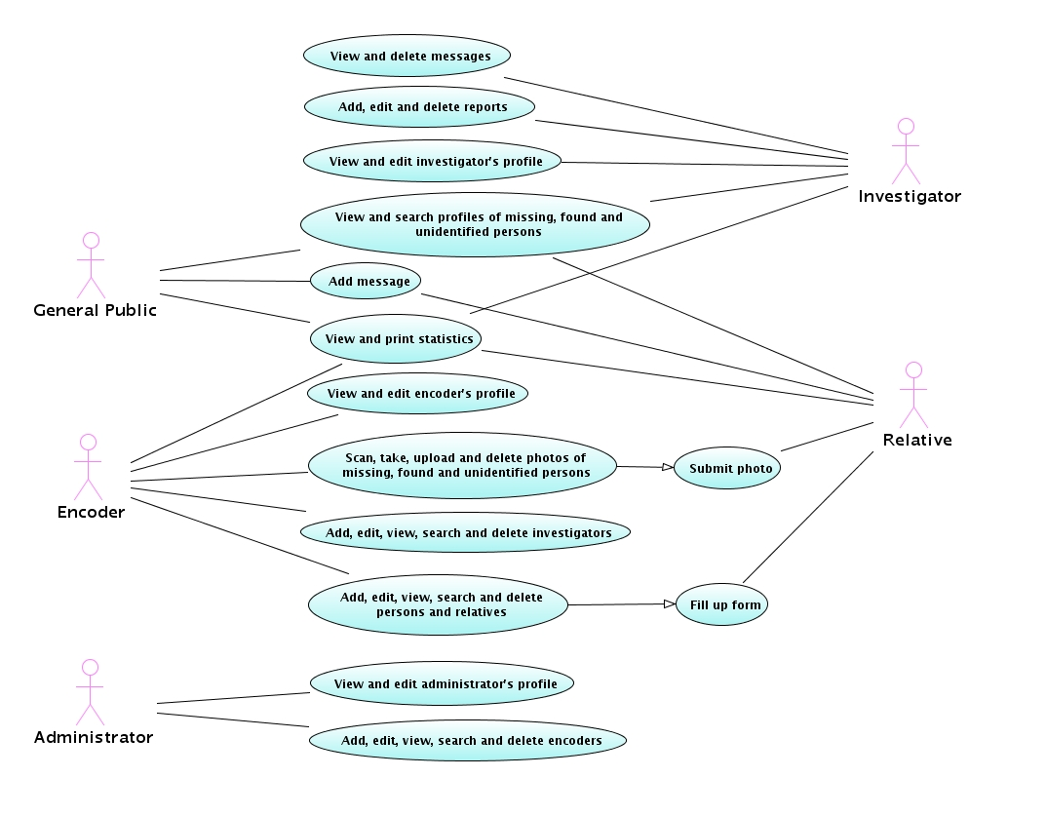Figure 1: Use case diagram of OpenMPIS.
Figure 2 describes the objects used in the system. Boundaries refer to Web pages, the controller is none other done the Struts ActionServlet that maps requested actions to matching entities and entities are the Java classes.

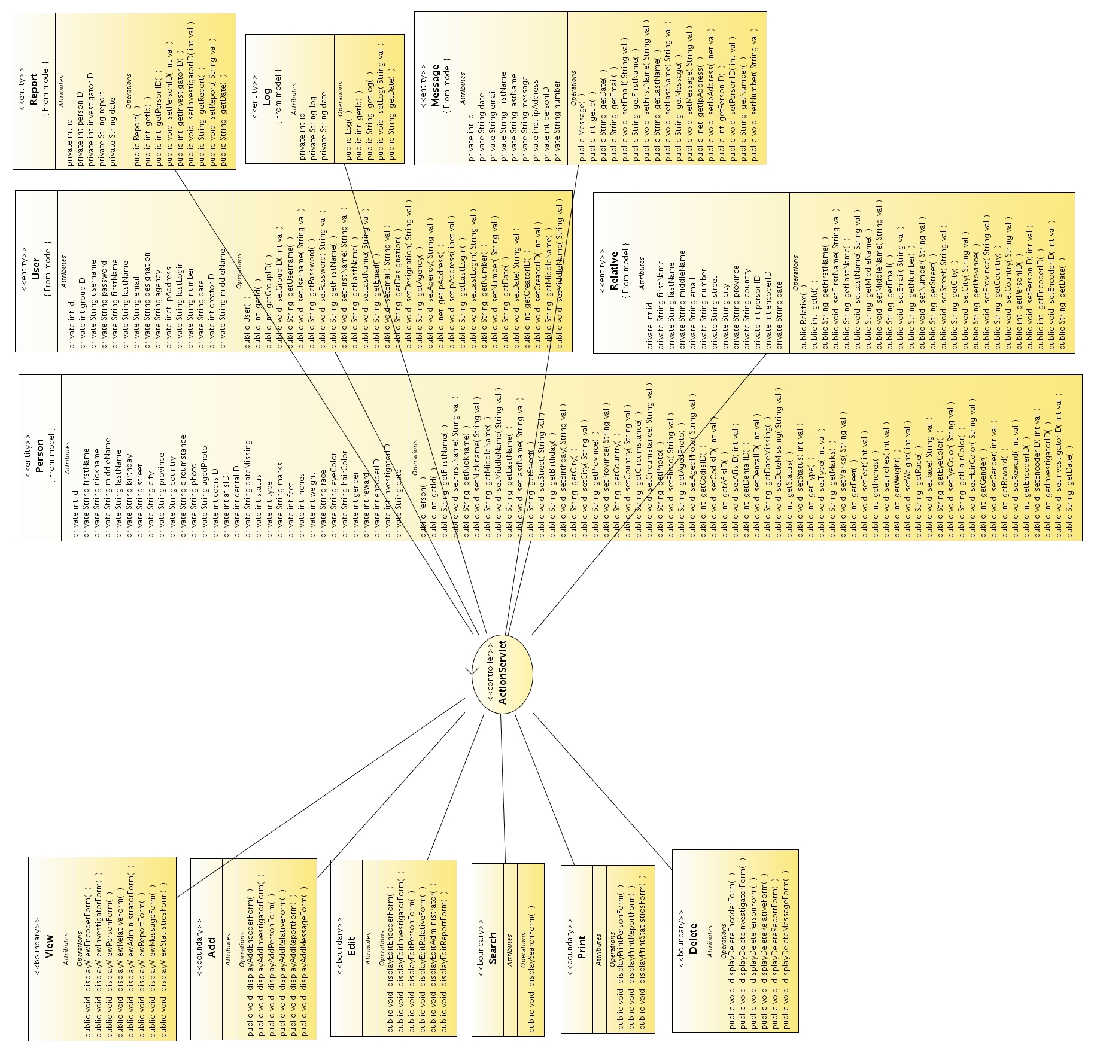Figure 2: Class diagram of OpenMPIS.
Figure 3 illustrates how an object retrieves and inserts data into the database. The Java object accesses the thread-safe, long-lived service object. This SQL Map Client service object accesses the SQL Map Configuration which connects to the database and reads the SQL Maps containing all the needed SQL statements. The Map Client returns the needed object.

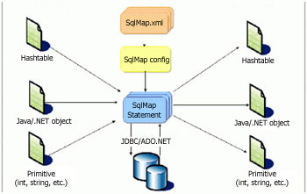Figure 3: Data model of OpenMPIS (iBATIS).
The OpenMPIS database schema was developed using Druid. It initially contains 6 tables, namely: person, relative, log, message, report and user (administrator, investigator and encoder). A missing, found or unidentified person's data will be stored on the person table. The relative who reports the person will be stored on the relative table. Database accesses will be added to the log table. The message table will contain information submitted by citizens pertaining to the missing or found person. User table stores the data on the administrator, investigators and encoders.
Figure 4 shows a snapshot of an online mind map created to visualize and organize ideas. It can be viewed at http://www.mindomo.com/view?m=68f5b9cf7c090593d0f29cb94497822c. It also serves as a project monitoring tool because it can reflect the progress of the modules.
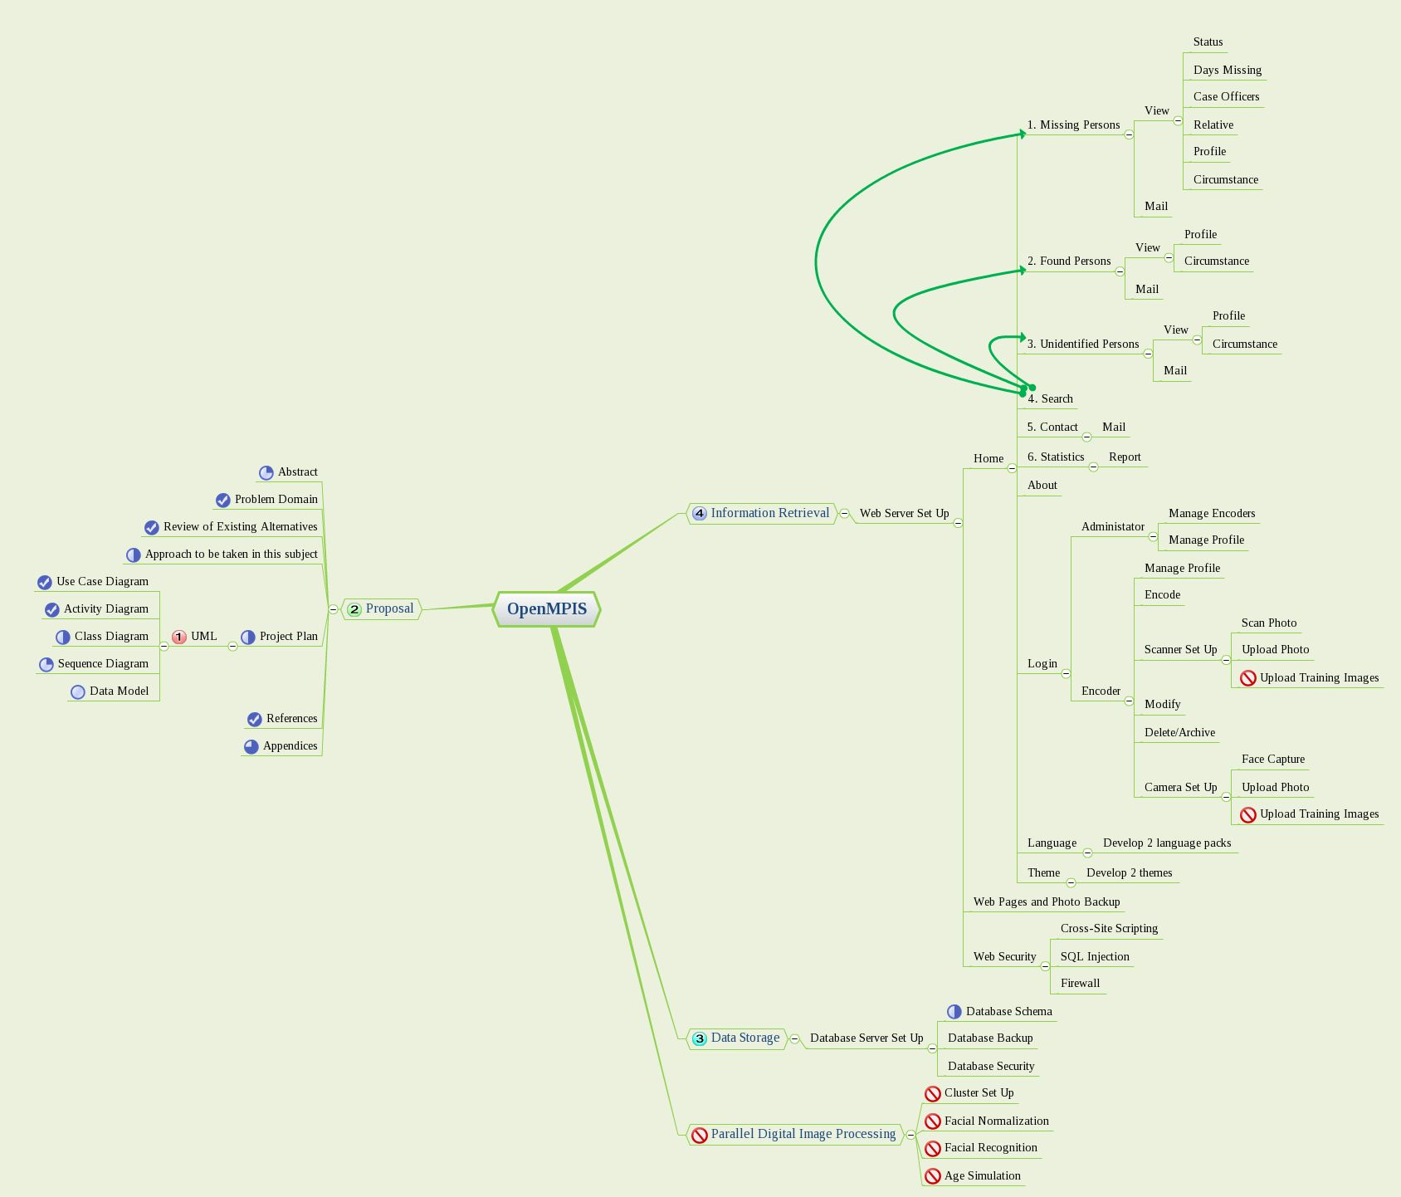Figure 4: Online mind map of OpenMPIS.
The following are the key features of the proposed design:
- Separation of the style and the text
To allow customization, themes using cascading style sheets will be used to change the look of the Web pages.
- Separation of the presentation or interface and the data or model through an intermediate component
The use of the MVC architecture will simplify the developer's concentration and aid in troubleshooting the application.
- Separation of the business logic and the persistence logic
The use of persistence framework through iBATIS' Data Access Object (DAO) instead of Hibernate's Object-Relational Mapping (ORM) was precipitated by DAO's simplicity, separation of data (DTO) and behavior (DAO), consideration for distributed architectures, lack of runtime container and capacity to generate highly efficient code (Grove, 2005). By separating business logic from persistence logic, the system can utilize any available database server.
- Separation of offline and online work
Visitors can easily copy statistical data right off the Web site or generate PDF versions. Encoders can also generate reports aside from statistics for record-keeping purposes.
- Separation of language-specific strings from hard-coded texts
To enable internationalization of the system, language-specific strings will be placed in resource properties. This will allow anyone to create texts for their locale. English and Tagalog versions will be available for the initial version.
- Separation of tasks among the various agencies
The administrator can create encoders from all cooperating agencies to encode a person's profile, contact information of the relative and delegate investigators to that case thus, dividing the workload to speed up dissemination and action.
- Incorporation of provisions for Parallel Digital Image Processing
Since the initial goal was to develop an age progression software, the database, form and interface will have certain elements that will take into account this particular upgrade.

B. Methods
For the design studies, the author has identified all possible users of the information systems; imagined what they should do with respect to the system; read books, articles and manuals on JSP, Java, Struts and iBATIS; and looked at various JSP applications for existing designs, standards and best practices. The author plans to gloss over new references as the project is being implemented.
In reviewing existing systems and related literature, the author browsed the Web for various operational missing persons information system from developed countries to understand how it works; checked Sourceforge for similar open source projects and attempted to locate at least one from the Philippines. the author even emailed government agencies involved in finding missing persons to ask them what they use or why there system is not operational but to no avail.
In assessing existing alternatives, the author simply read the description of projects under development, looked at screenshots, and tested the functional ones. A comparison of the finished information system against the Western counterparts can be made later.
A prototype will be produced and deployed on a sandbox which can be accessed publicly and tested by some personnels from the PNP, NBI and DSWD. The author can request his boss or a colleague to create a temporary domain name for the sandbox, preferably http://www.missingfilipinos.gov.ph. The author may be able to demonstrate this to some senators or any of the 3 agencies mentioned above.
In developing assessment instruments, the author will create test cases which can be carried out by friends or relatives to check if the desired results can be achieved. Bugs and recommendations will be grounds for revision of the prototype. Once all requirements or use cases have been fully satisfied, the author can conclude that the system is bug-free.
In preparing for the final project documentation/report, the author will refer to the IS295 guidelines and his undergraduate thesis for format and structure of content.

C. Plan for user testing and project assessment
The problem that was identified is the lack of a free, open source and operational information system currently available for download that could address lack of centralized service for disseminating advisories to and requesting help from the public and lack of consolidated effort for locating missing Filipinos. The project can be considered a success if all the requirements have been met, the code has been released into the public domain and a sandbox has been deployed for the country.
The author plans to focus his answers on the following questions: a.) how does implementing a missing persons information system integrate and consolidate government efforts in finding missing, abducted, runaway, throwaway and abandoned and reporting found and unidentified persons; b.) how can concerned citizens be informed and encouraged to look out for these missing persons; and c.) how can this information system promote awareness for the public in keeping their relatives safe.
The author plans to solicit the help of friends and relatives in conducting functional testing on the information system. The black box testers can play the roles of the administrator, encoder, investigator and concerned citizen; access an online document containing the test case; and append the results of their tests. The gathered test case results will determine if all key features and functionalities are working properly under any condition. The findings will also allow the author to pinpoint defects and rectify them immediately before it escalates and pose bigger threats.

D. Plan for collaboration (For collaborative projects only)
Not applicable.
V. Results and Discussions
VI. Conclusions
VII. Recommendations
V. References
Basham, B., Sierra, K. and Bates, B. (2004). Head First Servlets and JSP. Sebastopol, California, U.S.A.: O'Reilly Media, Inc.

Philippine Senate (2007). Jinggoy urges GMA to certify his bills as priority measures. http://senate.gov.ph/press_release/2007/0718_estradaj1.asp

Estrada, J. (2007). An Act Creating a Commission on Missing Persons. http://senate.gov.ph/lis/bill_res.aspx?congress=14&q=SBN-429

Villar, M. (2007). An Act Creating the Missing Persons Council, Prescribing its Powers, Functions and Duties and Providing Funds Therefor. http://senate.gov.ph/lis/bill_res.aspx?congress=14&q=SBN-1709

Legarda, L. (2007). An Act Establishing a National Strategic Missing Children Recovery Program and for Other Purposes. http://senate.gov.ph/lis/bill_res.aspx?congress=14&q=SBN-1385

Grove, A. (2005). Data Access Object (DAO) versus Object Relational Mapping (ORM). http://www.codefutures.com/weblog/andygrove/archives/2005/02/data_access_obj.html

Schatten, A. (2006). The iBATIS Persistence Framework. http://best-practice-software-engineering.blogspot.com/2006/11/pub-ibatis-persistence-framework.html

Wade, M. (2005). General Systems Theory. http://www.istheory.yorku.ca/generalsystemstheory.htm

Heylighen, F. and Joslyn, C. (1992). What is Systems Theory? http://pespmc1.vub.ac.be/SYSTHEOR.html

Walonick, D. (2004). General Systems Theory. http://www.survey-software-solutions.com/walonick/systems-theory.htm

Wikipedia 1. Systems Theory. http://en.wikipedia.org/wiki/General_systems_theory#Software_and_computing

Wikipedia 2. Software Design. http://en.wikipedia.org/wiki/Software_design

iBATIS. http://ibatis.apache.org/flow.jpg

Nelson, E. (2007). Open Architecture for the Enterprise. http://www.ibm.com/developerworks/library/ar-openarch1/index.html

Wikipedia 3. Black Box Testing. http://en.wikipedia.org/wiki/Black_box_testing
VI. Appendices
A. Deliverables and Milestones
This proposal will be submitted by the end of the semester. It will be reviewed and hopefully approved before the start of the next semester.
The working prototype will be submitted as part of the deliverables for the following semester and will be accessible online. The URL will be available later on.
The user testing and assessment plans and report of results will also be submitted next semester.
For the next version, an age progression feature using parallel digital image processing, tentatively dubbed Open Age Progression System (OpenAPS), should be implemented. The author plans to use a high-performance computing cluster as a computing platform; Java 2D API and mpiJava libraries for the software; and hundreds of pictures of Filipinos with varying ages as a dataset.
Training images or dataset will be composed of photos of male and female subjects belonging to any of these 7 age groups: 1-10, 11-20, 21-30, 31-40, 41-50, 51-60 and 61-80. These images will be stored on a file server and shared across the computing nodes. The aged progressed photo will be placed alongside the raw image.
For facial image normalization, pose compensation, illumination compensation and facial expression compensation are major issues to be resolved.
For facial image recognition, skin tone/region detection, YUV color domain, grayscale and principal component analysis algorithms will be evaluated to choose the most appropriate.
For the actual age Simulation, various implementations have been proposed like historical and consensus aging, linear aging, piecewise aging, support vector machines, dynamic Markov process, RBF neural network and Bayesian framework.
For the next release, statistical data can be overlaid on a Google map to create a visualization or geographic information of reported cases.
Likewise, to accommodate more clients, a study on how to set up additional servers and load balancer has to be undertaken.
The milestones of the project are the following:
Date Deliverables
03/01/08 Project proposal submitted
03/19/08 Project proposal approved
06/28/08 Design studies complete
08/30/08 Prototype design complete
09/06/08 Plans for user testing and project assessment complete
09/13/08 User testing and learning assessment complete
09/27/08 Presentation
09/27/08 Final report submitted

B. Budget
Total budget for the project is limited to Internet connection fees, printing costs, travel to UPOU and snacks for the panel. There is no need for procuring a separate development machine and a sandbox as the laptop computer will suffice.

C. Qualifications
The author has practical knowledge in the following programming and markup languages: J2SE, J2EE, C/C++, PERL, PHP, JSP, Servlets, CSS, Javascript, CGI and XHTML.
The author has extensive experience in using Linux (Red Hat, Fedora, Debian and Ubuntu), FreeBSD, Solaris and MS Windows. The author is adept with using and managing PostgreSQL and MySQL database servers, Apache Web server and Tomcat container.
The author is also skilled in IPv4 and IPv6 computer networking, OpenOffice and MS Office applications, cluster computing using MPICH2 and grid computing using Globus Toolkit 4.
Some of the author's accomplishments while working for the Advanced Science and Technology Institute are the following:
- set up the Philippine e-Science Grid Web site, wiki, monitor, test cluster, test grid and test certificate authority
- currently the team leader of the Philippine Bioinformatics Solutions project
- set up the Philippine Bio-Mirror node
- set up the Philippine S-Star node
- co-develop GenBank Entry Retrieval System
- set up test bed for voice over IPv6
- customize PhpMyLibrary Library Management System and Greenstone Digital Library for ASTI, LGRC and CHED
- deploy and document IPv6 network services
- test Z39.50 protocol functionality for PhpMyLibrary
- co-develop Pawikan Network Management System
- set up APBioBox and SunBioBox
The papers the author has written, co-written, published and presented are:
- ASTI's Bioinformatics Initiative : Knowing APBioBox and Sun BioBox the Easy Way
  - presented at the 1st Annual Bioinformatics Conference and Convention of the Network for Integrative Multidisciplinary Bioinformatics Utilization Strategies (NIMBUS), Inc., International Rice Research Institute, October 15, 2004
- PAWIKAN : A Scalable Network Management System For Small, Medium and Large-Scale Networks
  - presented at the 5th National Conference on Electronics and Communications Engineering, Mapua Institute of Technology, November 26, 2004 and at the 20th APAN Meeting, Taiwan, August 23, 2005
- Grid Computing for Bioinformatics: A Review and Feasibility Study of the Available Grid Architectures, Software Packages and Database Systems
  - presented at the 8th National Electronics Communications and Computer Engineering Conference, PTTC, November 23, 2007
The author has also conducted PhpMyLibrary and Greenstone trainings for LGRC-NCR, LGRC-7, LGA, LGSP and CHED on various dates and venues.
The author has also attended the following trainings:
- Java Short Course from Diliman Computer Science Foundation
- Advanced Java Training from Virtual Center for Technology Innovation – Information Technology
- Southeast Asia International Joint Research and Training Program in High-Performance Computing Applications and Networking Technology at the National Center for High-Performance Computing in Taiwan
- Grid Camp 2007, WLCG Tier-2 and EU-IndiaGrid Workshop at the Academia Sinica in Taiwan
New knowledge, skill and experience the author plans to gain during his work on this project include Unified Modeling Language, Model-View-Controller architecture, internationalization of Web applications and iBATIS data mapping.
For his educational background, the author finished elementary at La Consolacion College – Iriga City with honors in 1995 and high school in 1999 as third honorable mention. The author graduated from UP Diliman on March 2004 with a degree of Bachelor of Science in Computer Science. The author was also a DOST Scholar at that time. The author immediately started working for the Advanced Science and Technology Institute before taking up Master in Information Systems 2 years later.

D. Contributors / Collaborators
Not applicable.

E. Resources
The resources the author needs for the project are a laptop computer as a development and test machine, Internet access for research purposes, free and open source software for the development environment and servers, books, documentations and others.
F. Complete Program Listing
G. Technical Reference
H. User Manual
I. Tables and Figures

